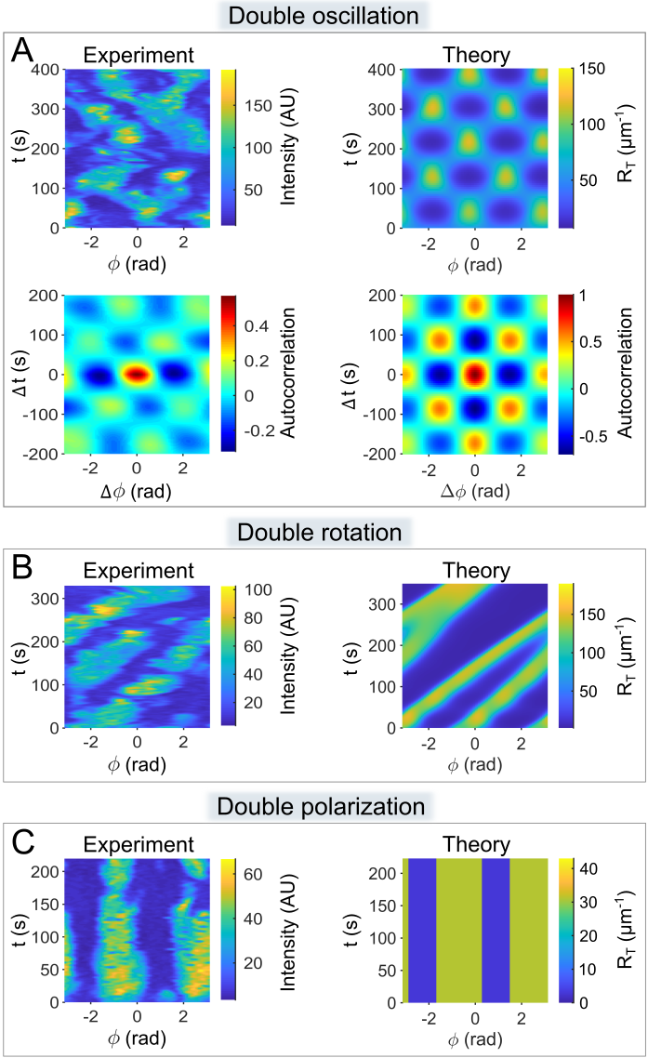

**S4 Fig.** **Comparison of the experimentally observed patterns of Rac1* with the patterns of Rac1T derived from computer simulations.** In panel A, the patterns are shown as kymographs (top) and the corresponding autocorrelograms (bottom). In panels B-C only the kymographs are shown. Kymographs and autocorrelograms are defined as described in Fig 4. The patterns shown correspond to the dynamics types shown in S1 Fig: (**A**) *Oscillating dipole*, (**B**) *Rotating dipole*, and (**C**) *Stationary dipole*. The parameter values used in the simulations are listed in S2 Appendix Table 1.